Name
Course
Tutor
Date
PSY330: M1 Assignment (40 points)

Q1. Descriptive statistics with SPSS (20 points total)
Run descriptive statistics to summarize the daily high and low temperatures in Phoenix during the month of November in 2018. Use the data set in the worksheet labeled “Q1” in the file “M1 Assignment Excel Data Set” for the following questions.

A. Create an SPSS data file from the provided Excel data set, either by copying and pasting the data points into the SPSS data file or by importing the data within SPSS. The SPSS data file must show the following:
- All three variables are present in the “Data View”
- Each variable is correctly configured in “Measure” under the “Variable View”
This data file must be submitted along with your Word document to earn these points.

B. Use SPSS to run descriptive statistics on HighTemp and LowTemp separately, in the month of November 2018. The descriptive statistics should include the following:
- Central tendency measures: Mean, median
- Dispersion (Variability) measures: Range, variance, standard deviation.
Descriptive statistics for High temperature
Statistics
HighTemp
N | Valid | 30
N | Missing | 0
Mean |  | 75.43
Median |  | 76.00
Std. Deviation |  | 5.494
Variance |  | 30.185
Range |  | 19

Descriptive statistics for Low temperature
Statistics
LowTemp
N | Valid | 30
N | Missing | 0
Mean |  | 52.17
Median |  | 51.00
Std. Deviation |  | 4.300
Variance |  | 18.489
Range |  | 15

C. Use SPSS to create a histogram for LowTemp. The histogram must display the following:
- Title of the histogram
- X and Y axes are labeled

D. Based on the descriptive statistics and the histogram, which central tendency measure and which dispersion (variability) measure best represent the LowTemp in November 2018? Why?
The histogram shows that there is a variation of the data across the chart which indicates that the data is skewed and does not follow a normal distribution. Therefore the best measure of central tendency that can be considered is the median because it is not influenced by the outliers. The standard deviation is a measure of dispersion which provides a better focus on the variation of the data.

Q2. Interpreting and graphing descriptive statistics (10 points total)
Use the worksheet in the M1 Assignment Data Set labeled “Q2” for the following questions. The data set contains the 2017 high school graduation rates for different counties in Arizona. The graduation rate is calculated by (Number Graduated)/(Number in Cohort), which are also included in the data set.

- Examine the data and then write a paragraph (3-5 sentences) to describe the data set. The graduation rate is the main focus, but you may also comment on the other two variables.

Based on the information that has been provided in data regarding the high school graduation rates across different counties in Arizona, Santa Cruz had the highest graduation rate of 90.5% while Apache County had the lowest graduation rate of 73.6%. Arizona has a high graduation rate of approximately 81.2%. Maricopa had the highest number in the cohort which was 56,332 students where 43,992 graduated representing a 78.1% which is lower than the state average. Santa Cruz had the lowest number in cohort, 778 where 704 students graduated indicating the highest graduation rate in the state at 90.5%.

B. Present the graduation rate data in a graph (not a table), using Excel. The graph must display the following:
- Title of the graph
- Axis labels or legend

C. Explain the rationale for your chosen type of graph. Why is your chosen graph the best way to display the data? (3 points)
The line graph provides a better visual representation of the different graduation rates across different counties. It is also easy to conduct comparative analysis across different counties because the differences are visible.
Q3. Interpreting descriptive and inferential statistics (10 points)
This question set is based on the following article:

Ball, K., Berch, D. B., Helmers, K. F., Jobe, J. B., Leveck, M. D., Marsiske, M., ... & Unverzagt, F. W. (2002). Effects of cognitive training interventions with older adults: a randomized controlled trial. Jama, 288(18), 2271-2281.

- Highlight the information in the following abstract that indicates the inferential nature of the data analysis performed in this study. Explain why it indicates inferential statistics. (2 points. 1 for highlighting appropriate info, 1 for rationale)
The study focused on determining whether three cognitive training interventions improve mental abilities and daily functioning in older, independent living adults. Thus determining the outcomes of the results, there is a need to incorporate a statistical analysis technique which can be used to infer. It is not possible to observe without inference the intervention that improves mental abilities without comparative analysis. The design and results of the study clearly show that inferential analysis was conducted where a p-value was obtained which was used to make a decision.

Abstract
Context: Cognitive function in older adults is related to independent living and the need for care. However, few studies have addressed whether improving cognitive functions might have short- or long-term effects on activities related to living independently.

Objective: To evaluate whether three cognitive training interventions improve mental abilities and daily functioning in older, independent-living adults.

Design: Randomized, controlled, single-blind trial with recruitment conducted from March 1998 to October 1999 and 2-year follow-up through December 2001.

Setting and Participants: Volunteer sample of 2832 persons aged 65 to 94 years recruited from senior housing, community centers, and hospital/clinics in 6 metropolitan areas in the United States.

Interventions: Participants were randomly assigned to 1 of 4 groups: 10-session group training for memory (verbal episodic memory; n = 711), or reasoning (ability to solve problems that follow a serial pattern; n = 705), or speed of processing (visual search and identification; n = 712); or a no-contact control group (n = 704). For the three treatment groups, 4-session booster training was offered to a 60% random sample 11 months later.

Main Outcome Measures: Cognitive function and cognitively demanding everyday functioning.

Results: Thirty participants were incorrectly randomized and were excluded from the analysis. Each intervention improved the targeted cognitive ability compared with baseline, durable to 2 years (P<.001 for all). Eighty-seven percent of speed-, 74% of reasoning-, and 26% of memory-trained participants demonstrated reliable cognitive improvement immediately after the intervention period. Booster training enhanced training gains in speed (P<.001) and reasoning (P<.001) interventions (speed booster, 92%; no booster, 68%; reasoning booster, 72%; no booster, 49%), which were maintained at 2-year follow-up (P<.001 for both). No training effects on everyday functioning were detected at 2 years.

Conclusions: Results support the effectiveness and durability of the cognitive training interventions in improving targeted cognitive abilities. Training effects were of a magnitude equivalent to the amount of decline expected in elderly persons without dementia over 7- to 14-year intervals. Because of minimal functional decline across all groups, longer follow-up is likely required to observe training effects on everyday function.

B. According to the abstract above, what is the sample and what is the target population in this study? (2 points, 1 for sample, 1 for population)

The sample was 2832 while the target population was persons aged 65 to 94 years recruited from senior housing, community centers, and hospital/clinics in 6 metropolitan areas in the United States.

C. According to the abstract above, what is the research question (or one of the research questions) for the study? What is the null hypothesis (in words) being tested by the inferential statistics? (2 points, 1 for research question and 1 for the null hypothesis)

The research question
Is there a statistically significant difference in the three cognitive training interventions considered in improving mental abilities and daily functioning in older, independent-living adults.
The Null hypothesis (Ho):
There are no statistically significant difference three cognitive training interventions considered in improving mental abilities and daily functioning in older, independent-living adults.

D. Answer the questions based on the table below: (2 points, 1 for each question)
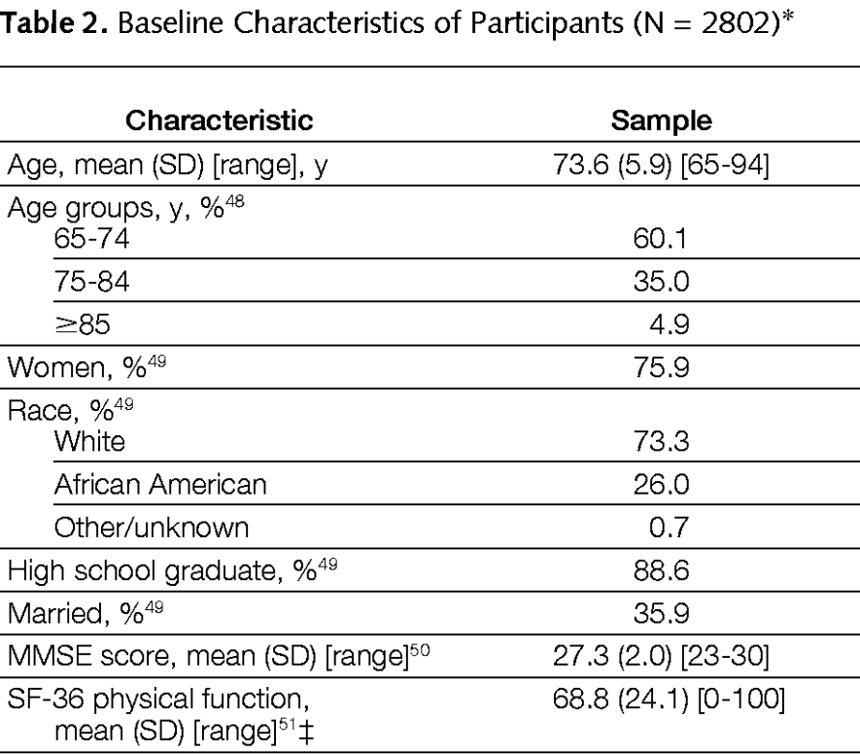

-Does the table show descriptive or inferential statistics? How do you know?
-Pick one variable from the table and discuss the statistics associated with it.

The table shows descriptive statistics because the information included in the table revolves around the mean, standard deviation, and range which are measures of central and dispersion. One variable from the table is age, the table shows that mean age of the participants in the study was 73.6 with a standard deviation of 5.9, and the range of age of participants varies from 65 to 94 years.

E. Answer the questions based on the table below: (2 points, 1 for each question)
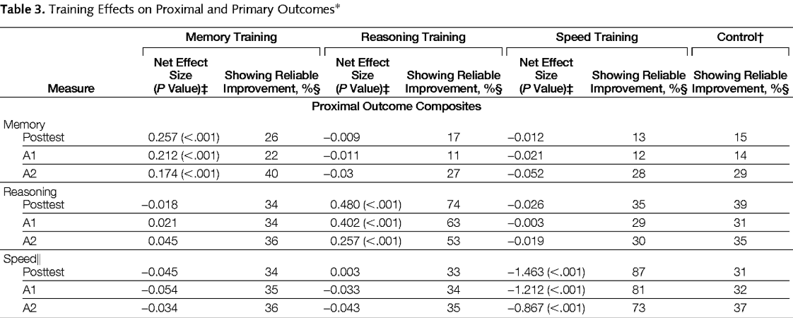

-Which part of the table shows inferential statistics? How do you know?
-Pick one variable from the table and discuss the finding from the inferential statistics associated with it.
The information that is provided in this table is inferential statistics because the results are being compared with a standard p-value. The three categories that are considered include memory, reasoning, and speed. The results show that there is a statistically significant difference in memory among the participants since the p<0.05.

